# Laboratory 1: Introduction to VMware

## 0. Introduction

This lab will introduce you to the VMware virtualisation software and guide you through installing a Virtual Machine (VM) with a guest operating system (OS). It will illustrate some of the features of VMware that will be covered in more detail in future lectures and used in the subsequent practical sessions.

The term *virtualisation* broadly means **the separation of a service request from the underlying physical delivery of that service**. With computer virtualisation, an additional layer is added between the hardware and the OS. This virtualization layer allows multiple operating system instances to run concurrently within virtual machines on a single computer, dynamically partitioning and sharing the available physical resources such as CPU, storage, memory and I/O devices.

The lab contains three main topics:

1. VMware Workstation 14 walkthrough

2. Create a client VM hosting a guest OS

3. Working with a VM

## 1. VMWare Workstation 14 Walkthrough

* 1. Open a VM (use it to open a previously created VM). Either in the main page or in File Menu -> Open.

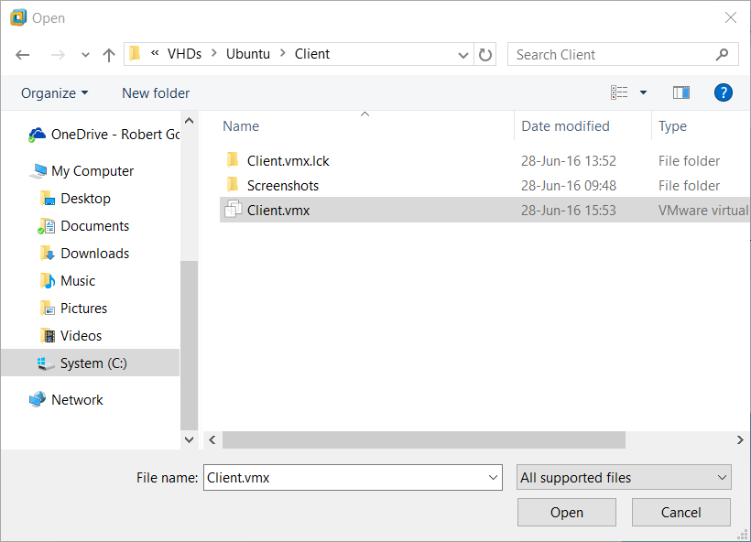

**Note**: We will be covering how to create a VM in more detail in Section 2.

* 1. File Menu

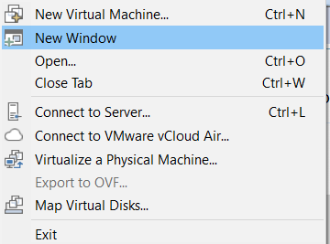

* 1. Edit Menu

|  |  |
| --- | --- |
|  |  |

* 1. Library Toggle (view list of installed VMs, located in the left side).

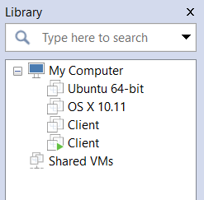

* 1. Thumbnail Toggle (switch between running VMs, located in the bottom). 
  2. VM options:

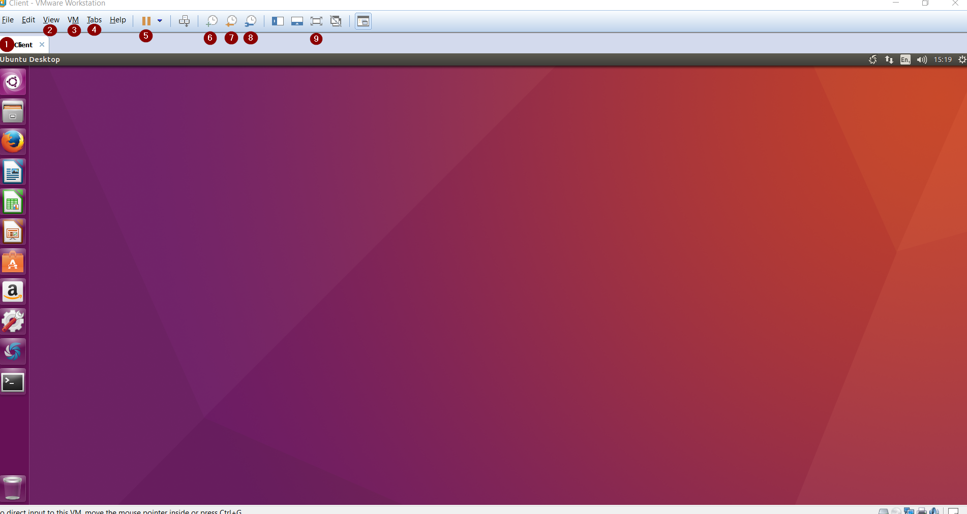

* 1. VM Name Tab: Display Name of VM and current status (offline, online, suspended)
  2. View Menu: Use this menu to adjust the workstation view settings between host and guest (VM).

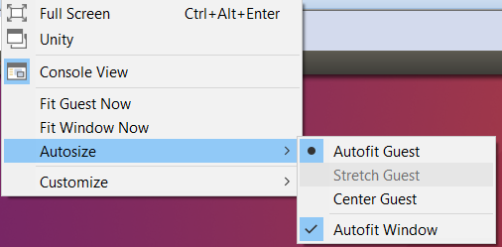

* 1. VM Menu

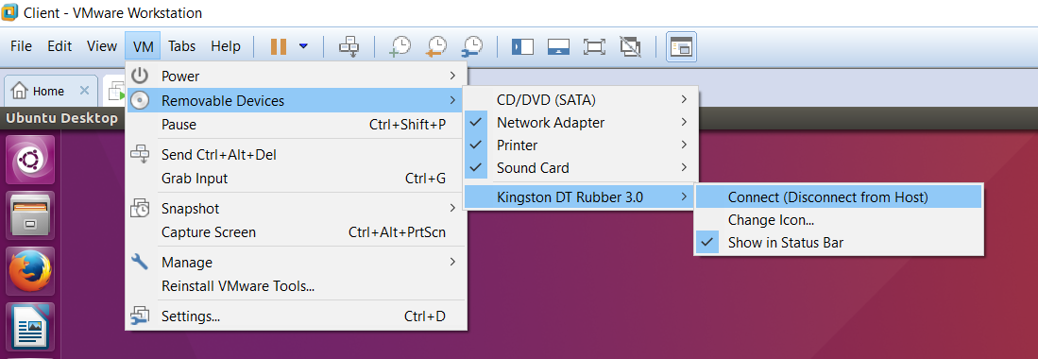

* + Use the VM menu to connect input devices and change settings
  + VM Settings – Note majority of these settings require the VM to be turned off to take effect.

|  |  |
| --- | --- |
|  |  |
| VM Hardware – Change the amount of resources (Memory/Processors) to allocate to your guest machine. | VM Options – Change various settings including shared folders and type of OS. |

* 1. Tabs Menu: Use this menu to navigate between the current open tabs.

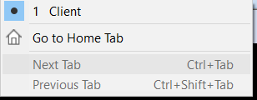

* 1. VM Power Menu: Use this menu to power on/turn off/suspend your VM.

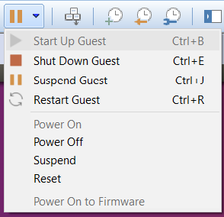

* 1. Take Snapshot 

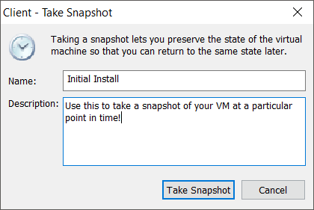

* 1. Restore Snapshot 

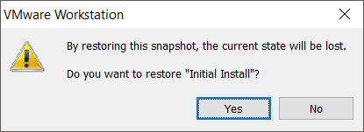

* 1. Snapshot Manager 
  + Use this to restore/delete any snapshots you’ve created.

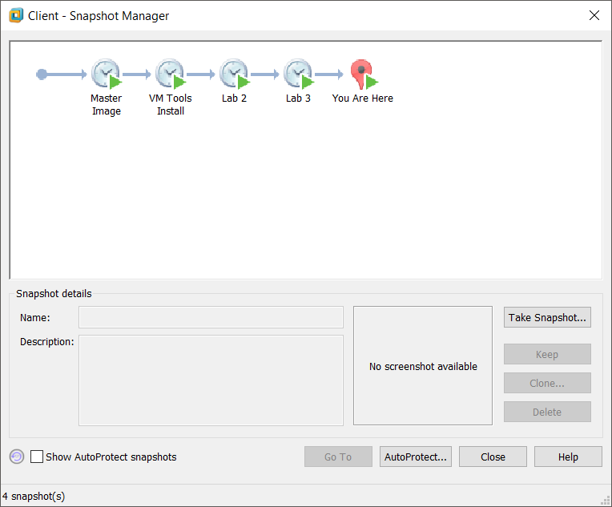

* 1. Full Screen 

**Note**: We will be covering snapshots in more detail in Section 3.

## 

## 2. Creating a Client VM hosting a guest OS

### Activity 1.1

### Create a virtual machine

**Approx. Time Required:** 15 minutes.

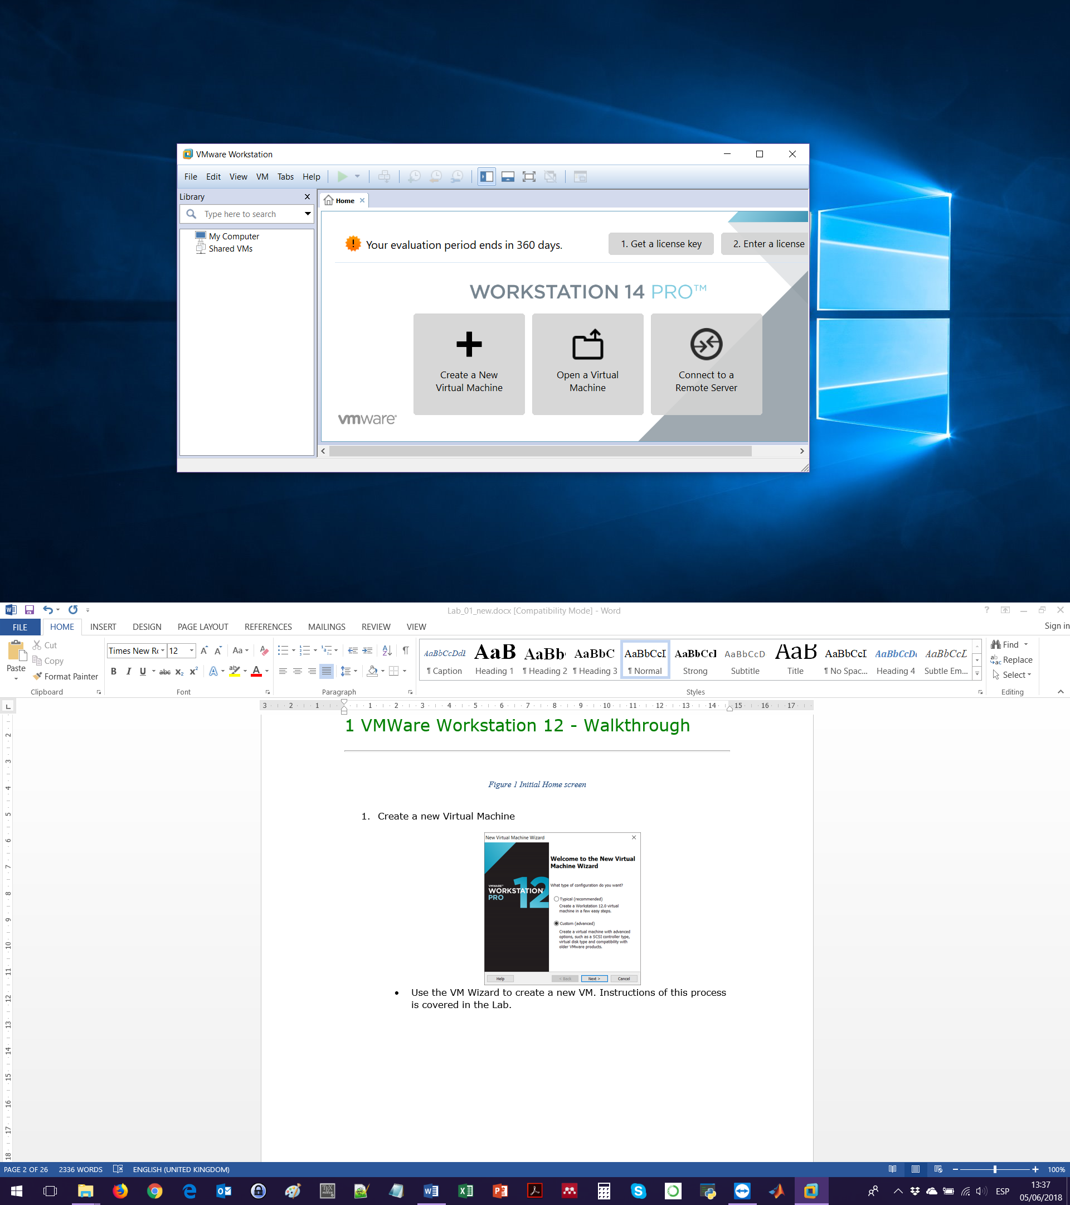

1. Launch **VMware** and select Create a New Virtual Machine. Select the Custom option.

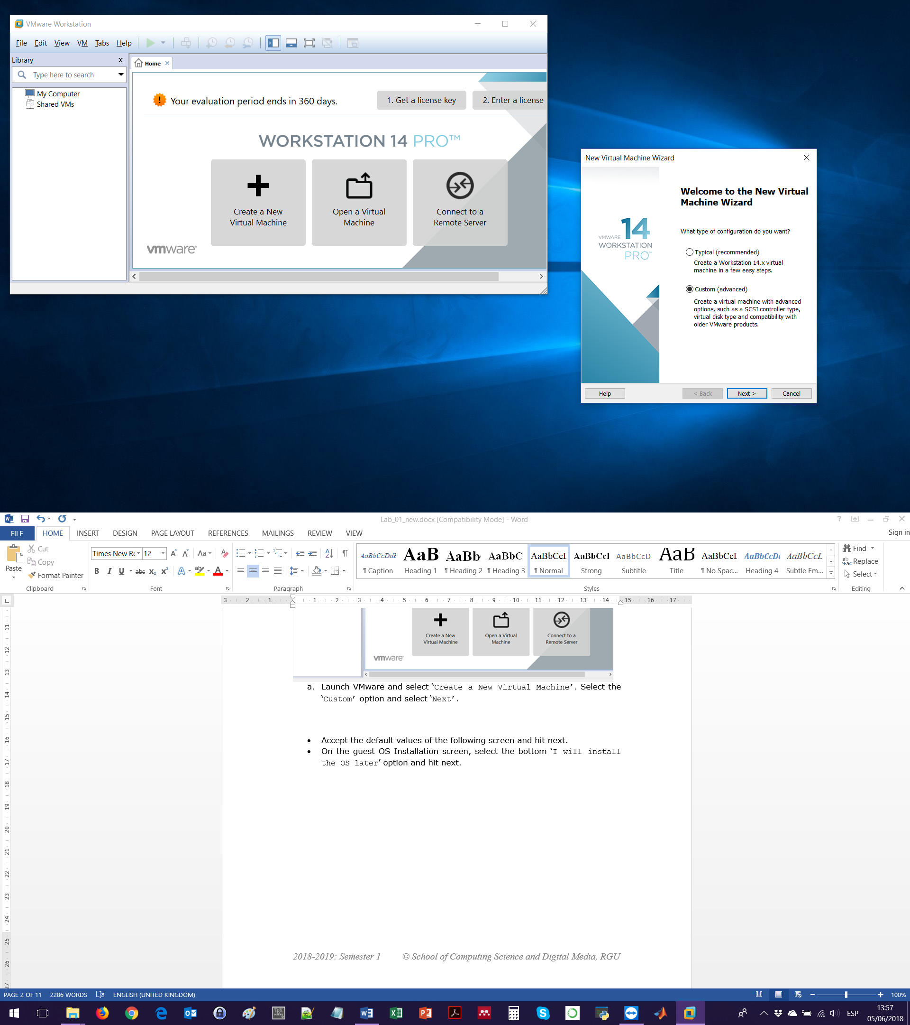

1. Accept the default values of the **Choose the Virtual Machine Hardware Compatibility** screen.
2. On the *Guest OS Installation* screen, select the option I will install the OS later.

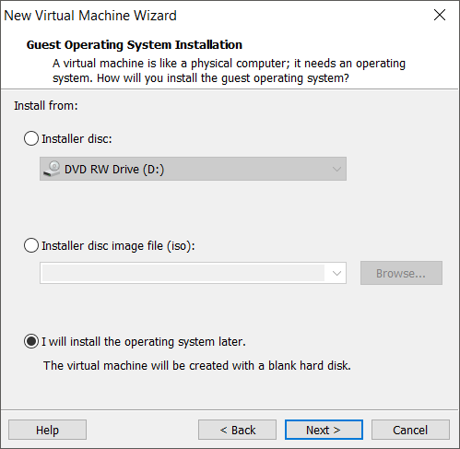

1. On the **Select a Guest Operating System** screen, choose Linux and Ubuntu 64-bit from the dropdown menu.
2. On the **Name the Virtual Machine**screen, change the Virtual machine name to Client. Change the save location by clicking on the Browse button. Navigate to C:\\VMWareVMs\Ubuntu\Client. NOTE: If you do not change the save location from the H: drive, your image will not be usable.

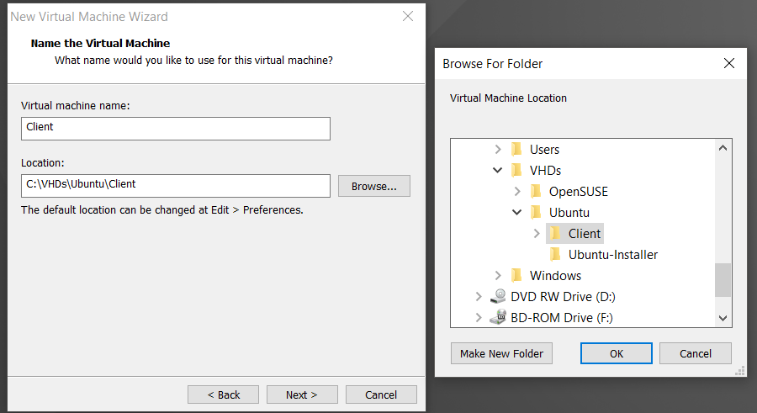

1. In the **Processor Configuration** screen, select 2 cores per processor from the drop-down menu.

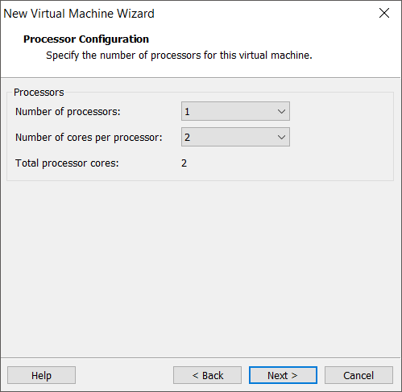

1. In the **Memory for the Virtual Machine** screen, use the slider to select 1GB of RAM (or type 1024 MB in the text box to the upper right of the screen).

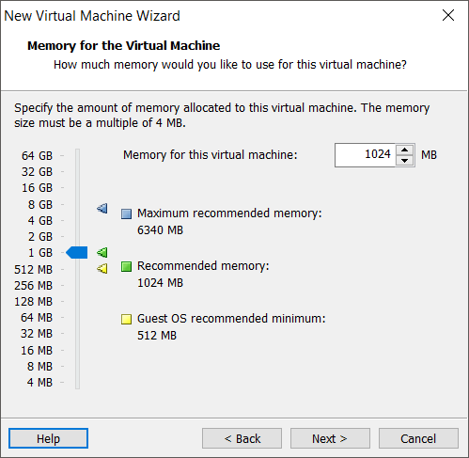

1. In the **Network Type** screen, change the network adapter type to Use network address *translation* (NAT).
2. In the **Select I/O Controllers Types** screen, accept the recommended selection *LSI Logic*.
3. In the **Select a Disk Type** screen, keep the default virtual disk type SCSI.
4. In the **Select a Disk** screen, ensure Create a new virtual disk is selected.
5. In the **Specify Disk Capacity** screen, keep the maximum disk capacity at 20GB and ensure that the store virtual disk as a single file option is selected.
6. In the **Specify Disk File** screen, click browse and navigate to C:\\VMWareVMs\Ubuntu\Client directory as depicted below.

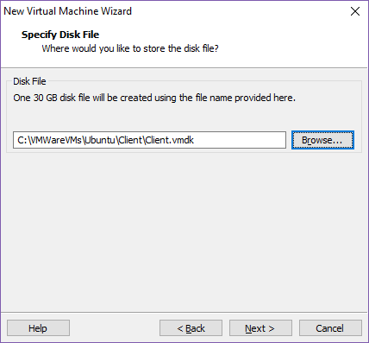

1. On the **Ready to Create Virtual Machine** screen, review the summary and click Finish. Now that you have created the VM, it’s time to install the OS. The screen shot below shows the Dashboard for the image that you created in the previous section. You can see that all of the configurations that were outlined are visible from within the main window.

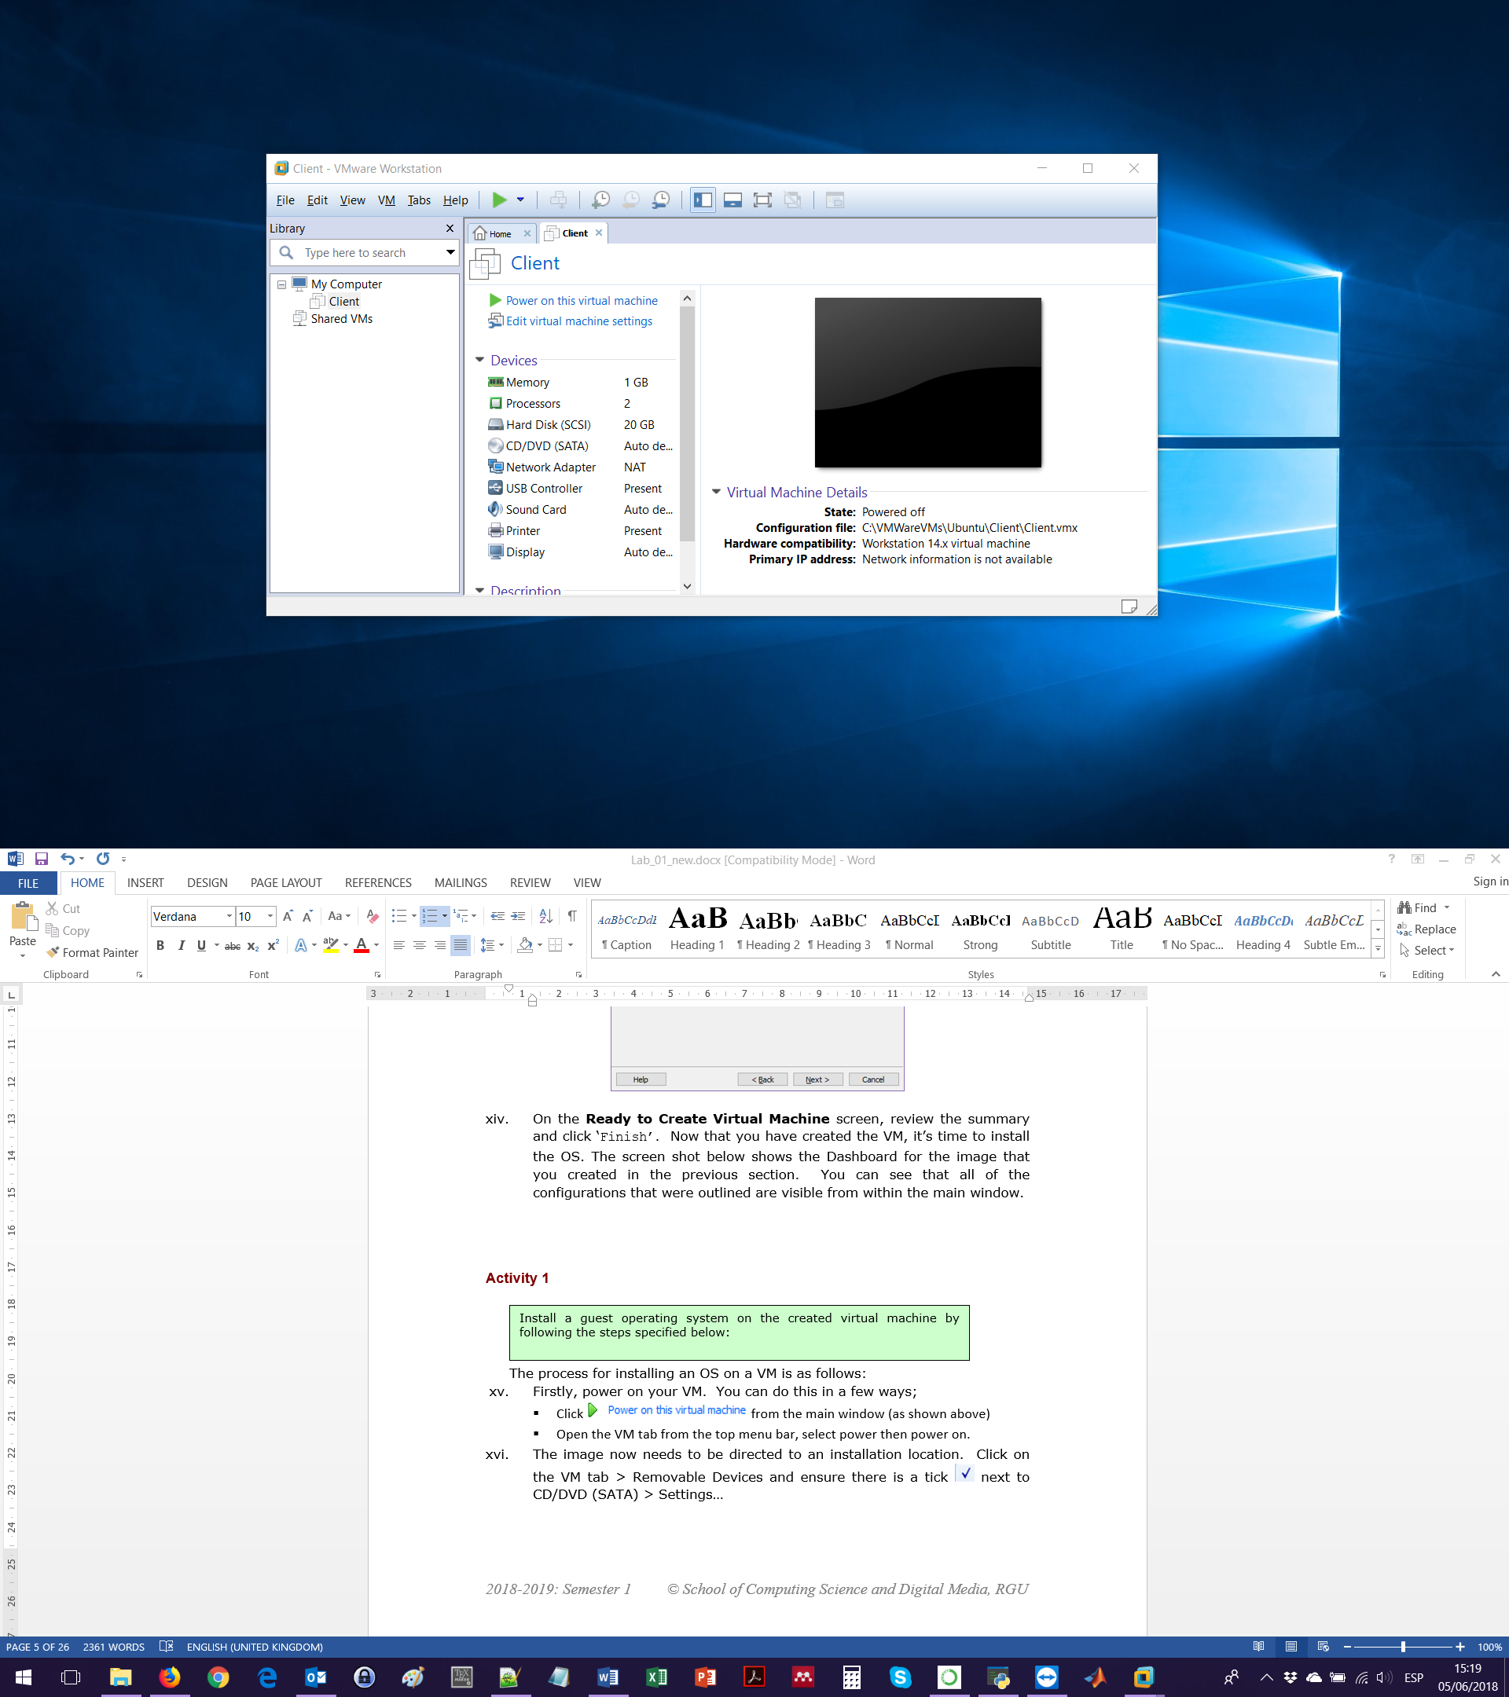

### Activity 1.2

### VM OS Installation

**Approx. Time Required:** 20 minutes.

**Objective:** Install a guest operating system on the created virtual machine.

1. Download the Ubuntu disk image ubuntu-16.04-desktop-amd64.iso. It is available for free [here](http://releases.ubuntu.com/16.04/).
2. Power on your VM. You can do this in a few different ways;
   1. Click  from the main window.
   2. On the VM tab from the top menu bar, select Power and then Power on.
      1. If a message like this one appears, you need to boot your computer, enter to BIOS setup and enable Intel VT-x.

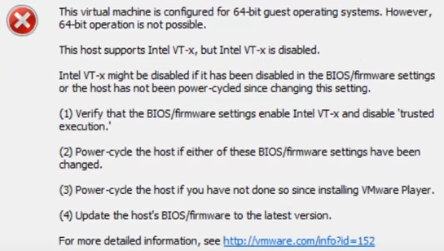

1. When the VM is turned on it will not find an OS. Thus, the image now needs to be directed to an installation location. In the VM tab click Removable Devices and ensure there is a tick next to CD/DVD(SATA).

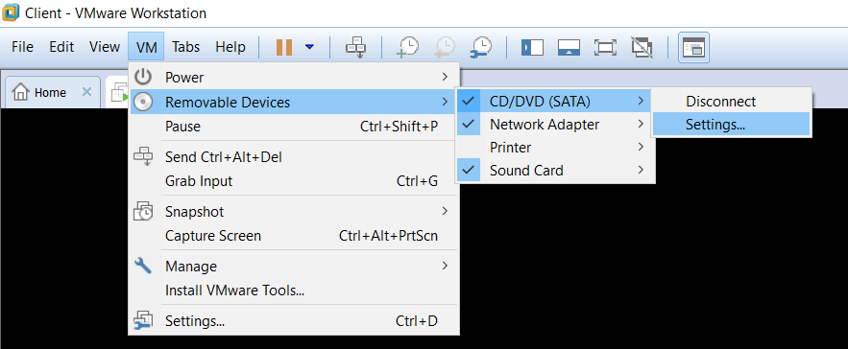

1. Go to Settings and in the new window, select Use ISO image file and click on the Browse button. Navigate to the location of the Ubuntu disk image. Click OK to exit the **Settings** window.

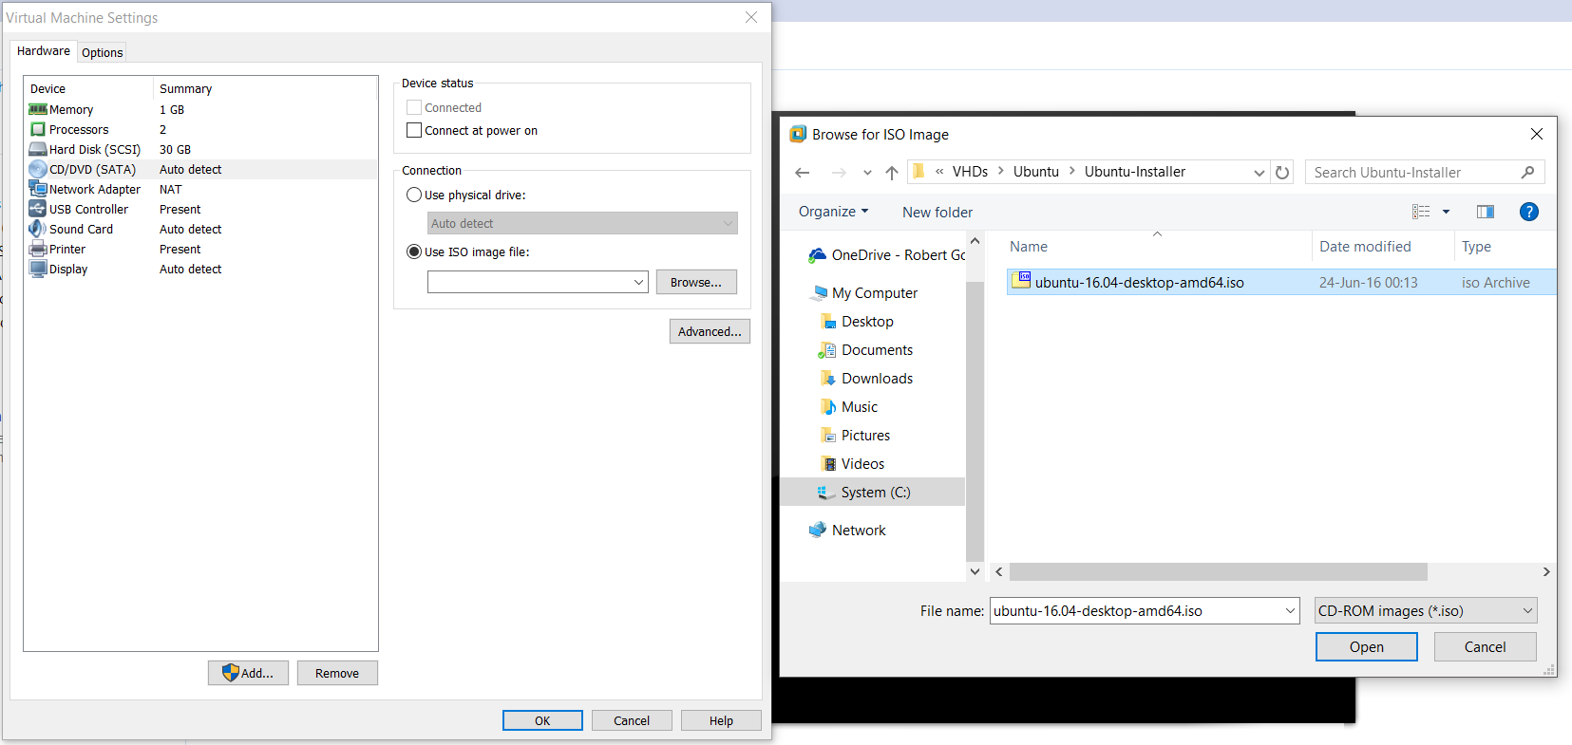

1. Now that the image has been directed to an installer, you need to restart the VM. To do this, in the VM tab select Power > Reset, and click OK on the warning message that pops up. Another option is to select Reset VM from the pop-up in the bottom of the VM screen.
2. In the **Welcome** screen, change the language to English and select Install Ubuntu.
3. In the **Preparing to Install Ubuntu** screen, select both Download updates while installing Ubuntu and Install third-party software.
4. In the **Installation type** screen, select Erase disk and install Ubuntu.
5. Click Continue on the **Write changes to disk** popup.
6. In the **Where are you?** screen, ensure the right location is set.
7. In the **Keyboard layout** screen, change the language and keyboard settings to English (UK).
8. At the **Who are you?** screen, enter the following information:

• Your name: student

* Your computer’s name: **STUDENT ID**-client

• Username: administrator

• Password: P@ssw0rd (Note: The ‘P’ is capitalised and the ‘0’ is a zero).

• Select Log in automatically.

1. Click Continue to complete the installation process. The installation process takes several minutes to run.

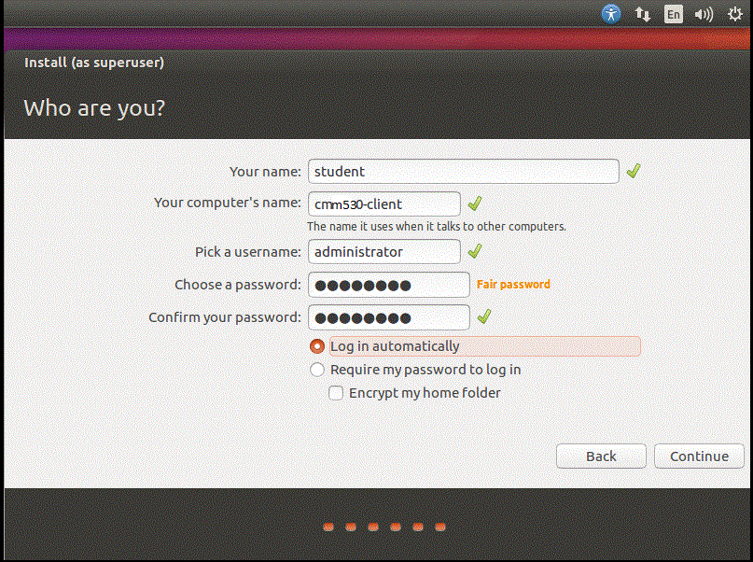

1. Once it’s complete click the Restart button. If a message saying assuming drive cache write through appears and the OS doesn’t start, then manually restart the VM.
2. The first thing to do when the Ubuntu installation is complete and you arrive to the desktop for the first time, is to install the *open-vm-tool-desktop* package. This will let you interact with the VM a lot more smoothly and it fixes auto resizing issues.
3. To do this, click the **UBUNTU DASH** on the **Launcher** (top icon in the toolbar on the left side of the screen).
4. Type in Terminal in the search bar and select the Terminal Application.

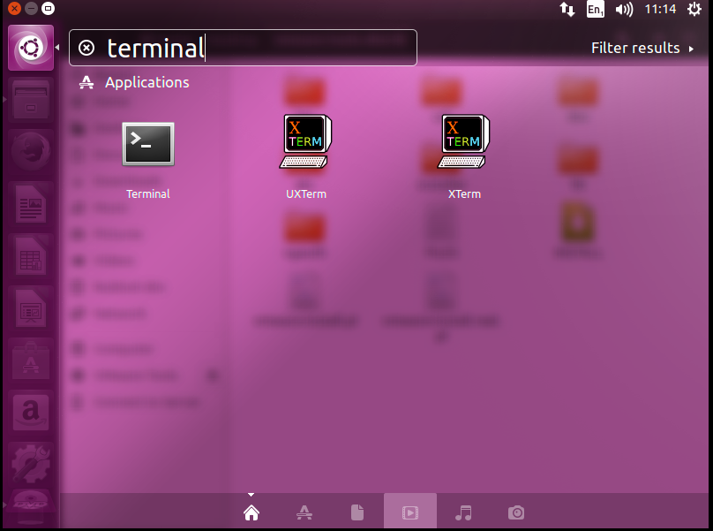

1. A terminal window will appear. To keep the terminal on the launcher – right click of the terminal icon and select lock to launcher.
2. To install open-vm-tools desktop, please enter the following command in terminal:
   1. sudo apt-get install open-vm-tools-desktop

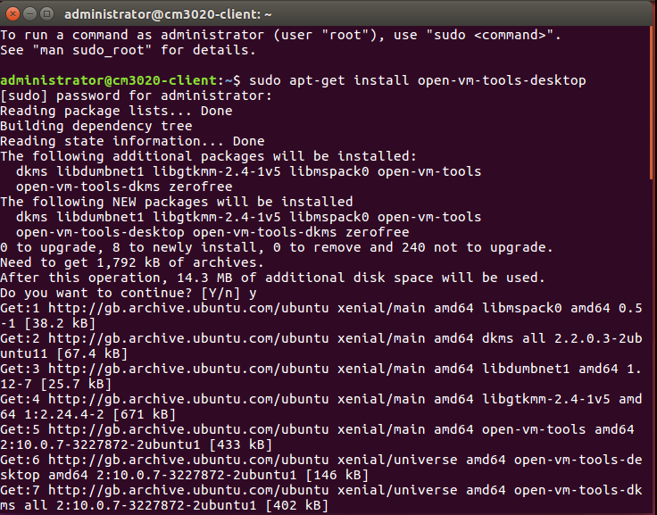

* 1. When asked **Do you want to continue**, enter Y.
  2. Once it’s complete, type reboot.

1. In addition to installing *open-vm-tools desktop*, another VMware toolset is required:
2. Open the terminal window.
3. To install git, type the following command:
4. sudo apt-get install git
5. When asked **Do you want to continue**, enter Y.
6. Then, we need to clone the vmware-tools-patches repo from github:
   1. git clone https://github.com/rasa/vmware-tools-patches.git
7. Once the repo is cloned, enter the following commands:
   * 1. cd vmware-tools-patches
     2. sudo ./patched-open-vm-tools.sh
     3. When asked **Do you want to continue**, enter Y.
8. Once it’s complete, type reboot.
9. To fix the low display resolution, go the **Settings** gear at the top right of the screen and select System Settings:
   1. Select **Screen display.**
   2. From here change the screen resolution to 1360x768 (16:9).
   3. If the confirm button is out width the display, then press the tab button 7 times.

|  |  |  |
| --- | --- | --- |
| C:\Users\user\AppData\Local\Microsoft\Windows\INetCache\Content.Word\Lab1 - Ubuntu System Settings .png |  |  |
|  | | |
| C:\Users\user\OneDrive\RGU\Work\CM3020 Operating Systems\New\Screenshots\Lab1 - Ubuntu Display Settings .PNG | | |

* 1. Finally, to let workbench auto resize the VM go to View 🡪 Auto Size and select auto fit guest and Auto Fit Window. Restart the VM for all changes to take effect.

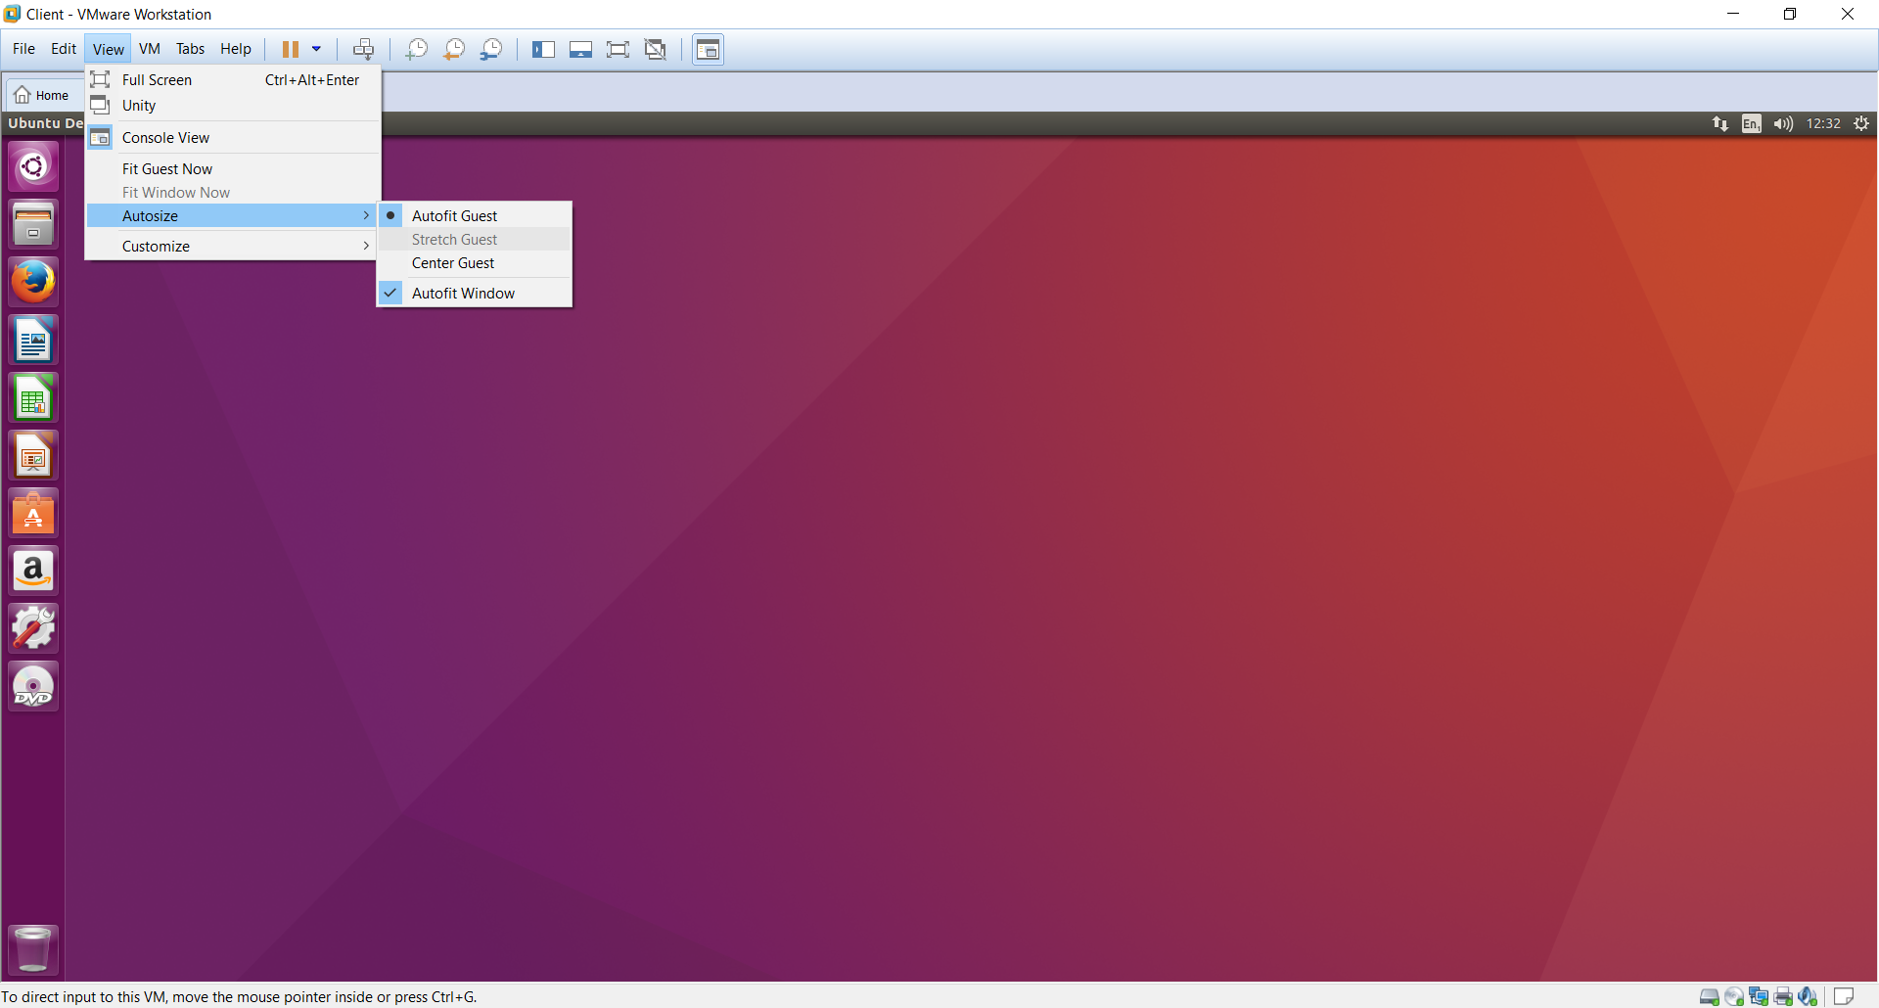

## 

## 3. Working with a Virtual Machine

* Press ‘ctrl’ & ‘alt’ keys to release the mouse pointer from the VM.
* To send ‘ctrl’, ‘alt’, ‘del’ to the VM, you need to use the key combination ‘ctrl’, ‘alt’, ‘insert’.

### Activity 1.3

### Setting the VM

**Approx. Time Required:** 20 minutes.

**Objective:** Familiarise yourself with the salient features of VMware Workstation by attempting to perform the following actions

### 3.1 Taking snapshots

Taking snapshots is like setting a system restore point in Windows, although snapshots are very easy to use and are faster to create and restore. **NOTE: You should proceed with caution as restoring a snapshot will overwrite any changes that have been made post snapshot creation.**

That said, the steps for creating and restoring snapshots are detailed below:

1. Turn the VM on.
2. To take a snapshot of the currently selected and running VM, click on the button from the toolbar as shown below.

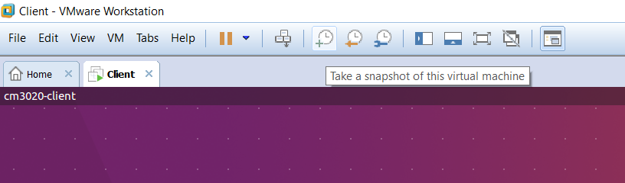

1. In the window that pops up, give the snapshot a sensible name and a description if applicable. If you have just installed the OS, it is good practice to take a snapshot and call it Master Image.

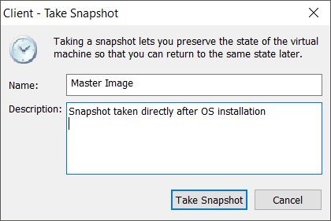

1. You can manage your snapshots by clicking the Manage snapshots for this Virtual Machine option.

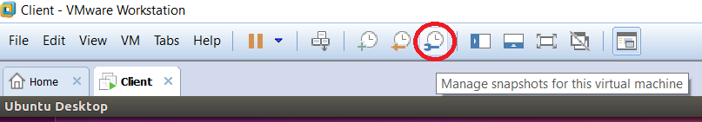

1. The Snapshot Manager gives an overview of the VM, showing a clear diagram of the flow of snapshots. You can take new snapshots from this window, delete current ones and also clone current snapshots.

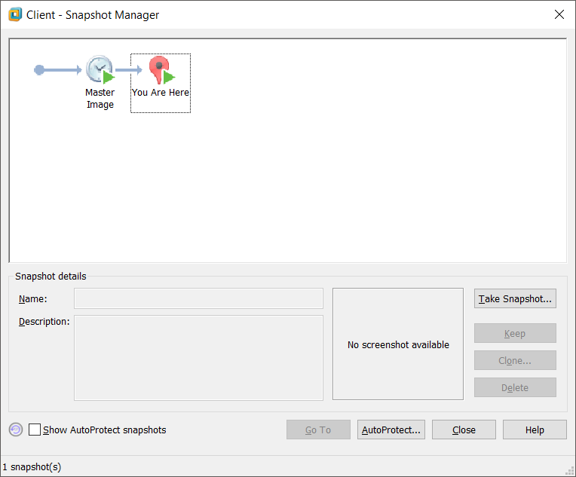

1. To restore a snapshot, click on Revert to previous snapshot from the toolbar. A message window will popup explaining that the current state of the machine will be overwritten by completing the action.
2. Clicking Yes on the popup window will restart the image and complete the task.

### 3.2 Saving

Over the course of this module you will be creating content that you want to save. As each student is free to use whichever machine they like, we advise that you save your work to a USB drive or to the host machine, and from there save to your H: drive.

#### 3.2.1 Saving to USB

1. Insert your USB stick. Navigate to VM > Removable Devices. Hover over your USB device and select the Connect option from the list.



1. Note there are some compatibility issues with USB 3.0 drives. You can correct this by changing the compatibly level on the USB controller in the VM settings. If errors still persist, try using the drive in a USB 2.0 port.

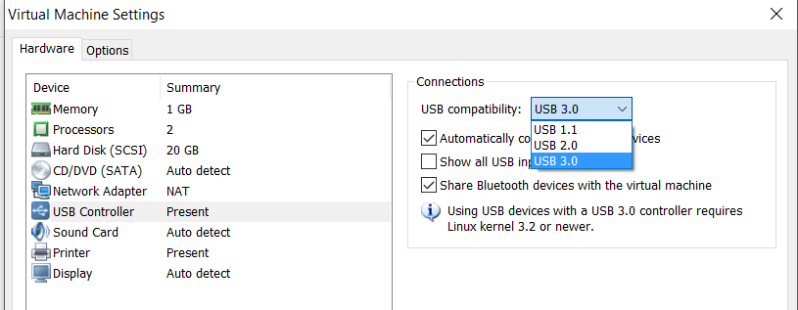

1. You can either access your USB through the **Nautilus file management** utility (on the Unity Launcher as shown in the screenshot below).

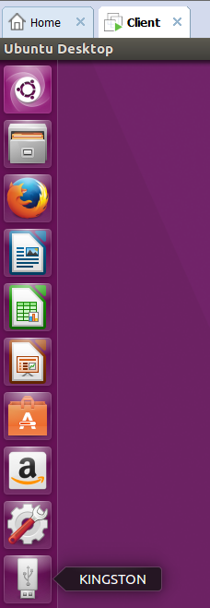

1. Alternatively, you can access the USB through the terminal using the /media reference. For instance, in the terminal you can move data using the mv command, as shown below.

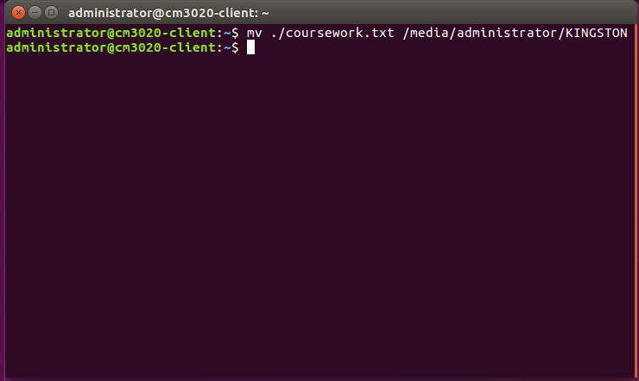

#### 3.2.2 Saving to local hard disk of host machine

1. To save data from the local host hard disk to the VM you have to enable the shared folders.
2. Ensure the VM is offline.
3. To access the shared folder settings, go to the Virtual Machine Settings (CRTL+D) and then select Options.
   * 1. For the Shared Folders setting, ensure that Always enabled is selected.
     2. Click Add.
     3. On the **Welcome to the Add Shared Folder Wizard** window, click Next.
     4. On the **Name the Shared Folder** window, browse to the C:\\VMWareVMs folder and name it VMWareVMs. Then, click Next.
     5. On the **Specify Shared Folder Attributes** window, select enable this share and leave Read-only unticked.
     6. Finish and restart VM. You will find your shared files in the VM under Computer/mnt/hgfs/VMWareVMs.
        1. If this is not the case, first go the command terminal (in the VM) and type vmware-hgfsclient. This should show you the name of the shared folder VMWareVMs (If not, redo from step 3.2.2.i.a).
        2. With the VM on, click on **VM >** Settings, then disable and enable again the sharing. This should now show the shared folder in the client VM.

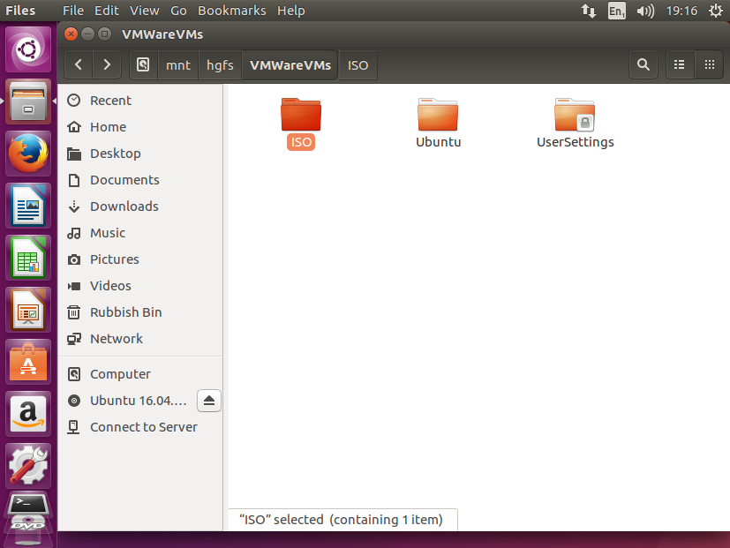

### 3.3 Troubleshooting

### 3.3.1 Importing VMs

VMWare will note be aware of any existing VMs on the local disk until you configure it for the first time. As you will have to do this every time you use a new machine, **we advise that you stick to using the same machine whenever possible.**

When this isn’t possible, and in the first instance of setting up your VMs, follow the instructions below:

1. File > Open… > C:\VMWareVMs\Ubuntu\Client\Client.vmx
2. In the main menu, power on the VM.
3. If you are prompted with the below pop up window, select ‘I copied it’.

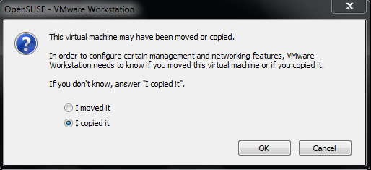

1. Right click on the VM tab and add to your favourites.

### 3.3.2 Ghost images

VMWare stores image details within a settings folder on your H: drive. Because of this, you may find that you have a lot of references to ‘ghost’ images that you used on other machines in the lab. When you try to run these images you will get an error message stating that VMWare was unable to find the file needed to run the VM. This is a known bug, and system admins are working to get around it.

### 3.3.3 Downloading Ubuntu to your own machine

For this module we will be using the (x64) bit version of Ubuntu 16.04 LTS (Long term support) which you can download from here:

<http://releases.ubuntu.com/16.04/ubuntu-16.04-desktop-amd64.iso>

However, you can also download the latest version of Ubuntu from the following address:

<http://www.ubuntu.com/download/desktop/>

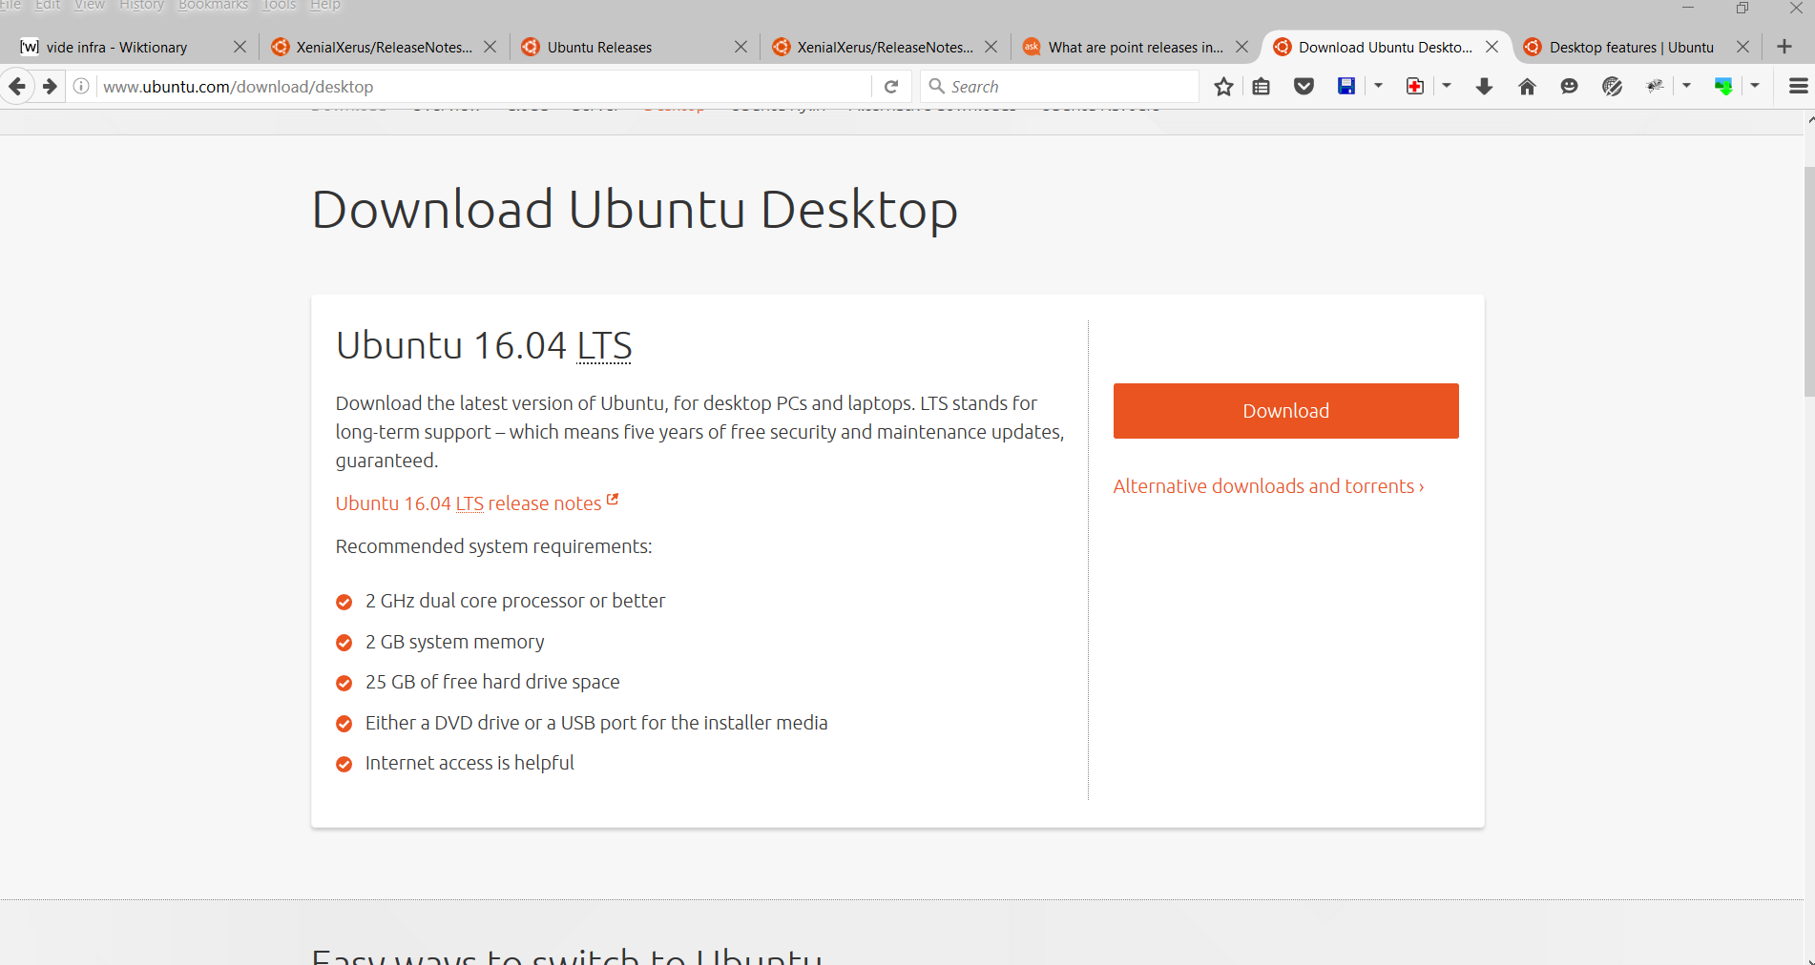

### 3.4 Overview of the Ubuntu Desktop

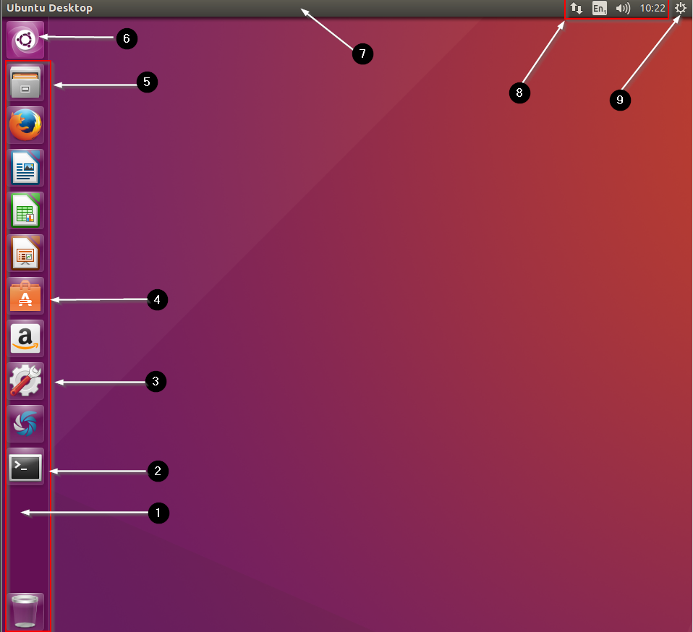

1. Ubuntu Launcher
   * Similar to the DOCK in Mac OSX, you can “lock” your favourite applications as shortcuts.
2. Terminal
   * Command line application interface – will be used extensively throughout the labs
3. Settings
   * All system-based settings can be changed from here.
4. Ubuntu Software
   * Similar to the App store/Google play/Windows Store you can download applications for Ubuntu from a central repository.
5. Files
   * Nautilus is the default file manager on Ubuntu
6. Ubuntu Dash
   * Similar to the spotlight function on MAC OSX – you can search for any application/file/setting on Ubuntu
7. Ubuntu Panel
   * When an application is opened – the panel will display options for that application if you hover over it.
   * To change the default behaviour, go to System settings – Appearance – Behaviour:

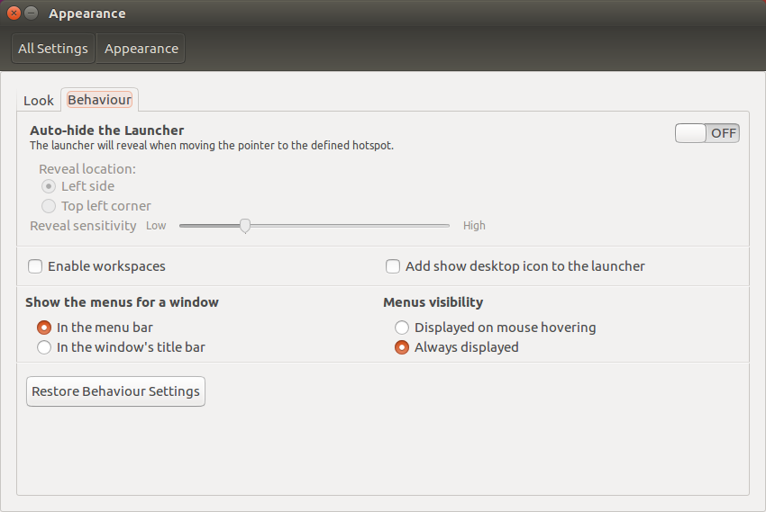

1. Status Menus
   * Similar to the taskbar on Windows, you can find status menus for networking, sound and background applications.
2. Shut down.

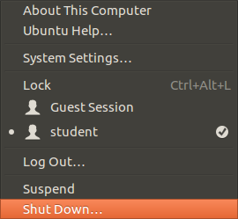

More hints and tips:

<http://www.howtogeek.com/113330/how-to-master-ubuntus-unity-desktop-8-things-you-need-to-know/>